Project Development Phase Project Development-Delivery of Sprint-1

|  |  |
| --- | --- |
| Team ID | **PNT2022TMID22772** |
| Project Name | **Real-Time River Water Quality Monitoring and Control System** |

To create the web Application using Node-RED for registration:

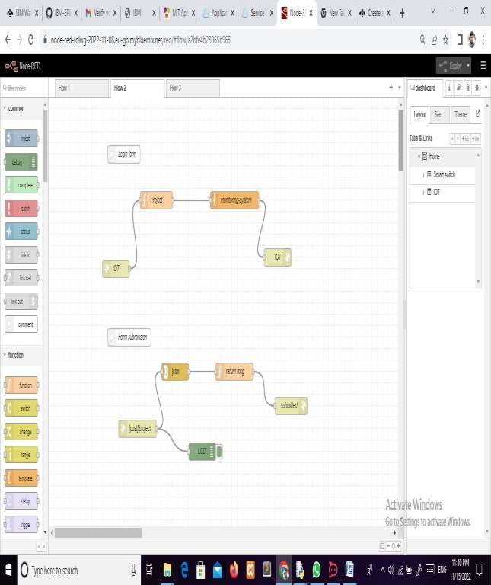

Workflow Diagram

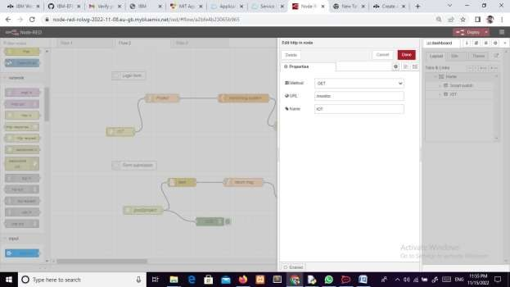

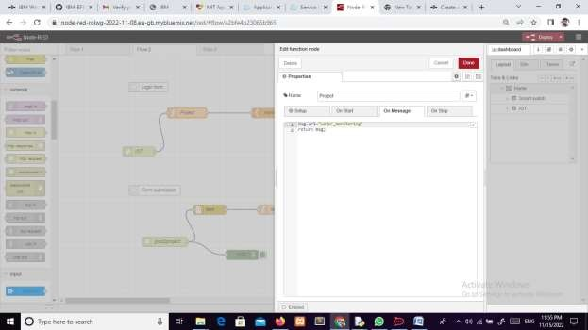

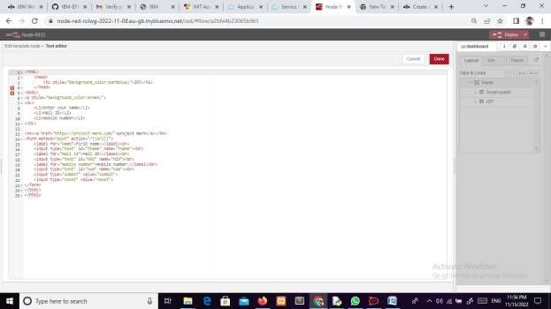

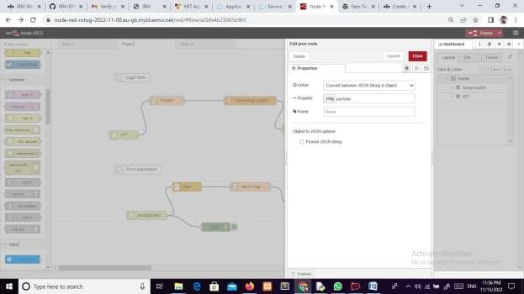

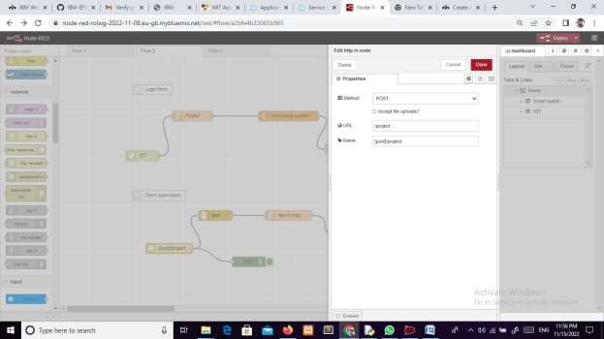

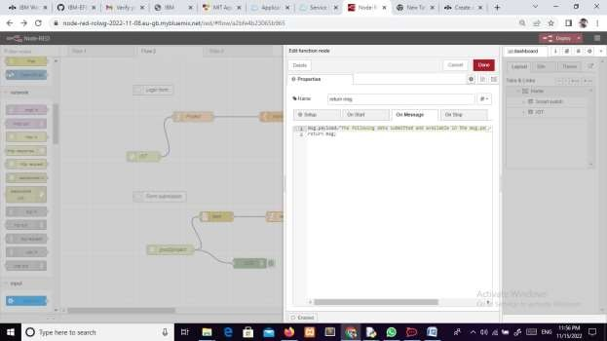

To use the above web application, put https://127.0.0.1:1800/IOT in browser and search.